PathSimR – Output Library

## Summary

1. **Base Datasets**
   1. *Capacity Calendar*
   2. *Variable arrival calendar*
2. **Patient-based metrics**
   1. Averaged over patients (Leaving per node & per rep) (mean, sd, IQR, 95%)
      1. Total time in system
      2. Wait
      3. Active Service
      4. Length of Stay
      5. Delay to departure
   2. Averaged over patients & reps (leaving per node) (mean, sd, IQR, 95%)
      1. Total time in system summary
      2. Wait summary
      3. Active Service summary
      4. LOS summary
      5. DTT summary
      6. Rejection Rate
   3. Summed over nodes & averaged over patients (leaving per replicate) (mean, sd, IQR, 95%)
      1. Replicate Patient Wait
      2. Replicate Patient LOS
      3. Replicate Patient DTT
   4. Summed over nodes & averaged over patients & replicates (leaving 1 line per metric) (mean, sd, IQR, 95%)
      1. Patient Wait
      2. Patient LOS
      3. Patient DTT
3. **Node-based metrics**
   1. *Overall df: avg_through_time (mean & percentile per metric)*
   2. % time at level – Collapse across all reps leaving node and level as factors
      1. Delayed, Transition & queue are unscaled and reflect the whole simulation
      2. Occupancy & Bed Occupancy are scaled by the occupancy calendar so rather than discrete values, they are decimals Vs % e.g. Unit A is half full 75% of the time given shifting capacity
   3. Percentiles
      1. Delayed, Transition & queue are derived as an inversion of the % time at level data
      2. Occupancy & Bed Occupancy are scaled, therefore the value given by percentiles will not correspond to an actual value in terms of beds but will give a decimal interpretation in relation to the capacity (and changes)
   4. Overall averages (top level summary) (Single line per node)
      1. Average # Delayed, in Transition, in the Queue and in the service point (patient occupancy and bed occupancy) can be given as actual values
   5. Average through time plot
      1. Figure showing the mean value of the metrics over the simulation along with the 50%, 95% & 99% data envelopes

## Definitions

* **Total time in system (TTIS)**
  + Time between external arrival and departure to an exit for each patient
  + Aggregation over patients & reps
* **Wait**
  + Time between arrival and service start
  + Aggregation over patients for per node drill down
  + Aggregation over nodes for patient pathway drilldown
* **Active Service** 
  + Time between service start and service end
  + Aggregation over patients for per node drill down
  + Aggregation over nodes for patient pathway drilldown
* **Time Delayed (Capacity Driven)**
  + Time between service end and transition delay start
  + Aggregation over patients for per node drill down
  + Aggregation over nodes for patient pathway drilldown
* **Time Delayed (Transition)**
  + Time between transition delay start and departure
  + Aggregation over patients for per node drill down
  + Aggregation over nodes for patient pathway drilldown
* **Length of Stay (LOS)**
  + Time between service start and departure (Active Service + Capacity Delay + Transition delay)
  + Aggregation over patients for per node drill down
  + Aggregation over nodes for patient pathway drilldown
* **Delay to Transfer (DTT)**
  + Time between service end and departure (Capacity Delay + Transition Delay)
  + Aggregation over patients for per node drill down
  + Aggregation over nodes for patient pathway drilldown
* **Rejection Rate**
  + Number of patients rejected from full external queues divided by the length of the simulation run
  + Aggregated over reps
* **Occupancy**
  + Number of patients who are receiving or have received service and are occupying a space in the unit.
* **Bed Occupancy (occ_bed)**
  + Same as occupancy above but also includes any beds that are currently reserved for patients under transition delay upstream
* **Transition Delay**
  + Number of patients concurrently experiencing a prescribed transfer delay
  + Patients moving to downstream nodes will also be reserving a space in the onward node and thus appear in the bed occupancy metric for that unit
  + Patients are included in the occupancy and bed occupancy of the current node
* **Capacity Driven Delay**
  + Number of patients concurrently delayed due to insufficient capacity downstream
  + These patients are included in the occupancy and the bed occupancy
* **Queue**
  + Number of concurrent patients who have arrived at a service point and are yet to start the service
* **% time at level**
  + Total amount of time (summed across all replicates) that the node existed at a certain metric level e.g. The queue at node A was 5 for 150 time units out of a simulation total of 1500 therefore is 10%.
* **Percentiles**
  + Percentiles are calculated as an inversion of the % time at level tables.
  + Find the interpolated value associated a percentile value and then ceiling the value to find the actual number of spaces needed.

## Events & Outputs Figure

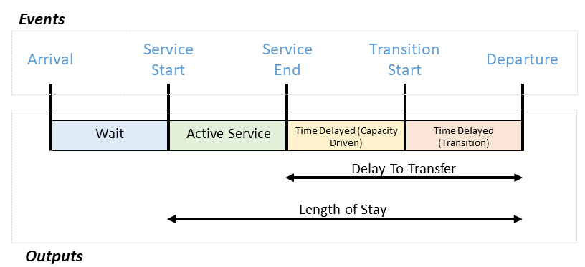

## Report Structure

1. Introduction describing the network
   1. # of service nodes
   2. Entry points
   3. Exits
   4. Important calendar features
2. Top level patient-based metrics (over simulation)
   1. Pathway summed values
   2. Node specific values
3. Top level node-based metrics (over simulation)
   1. % time at level metrics (per node) plot
   2. Percentiles (per node) table
   3. Average through time plot
4. Metric definitions (& examples)
5. Appendix